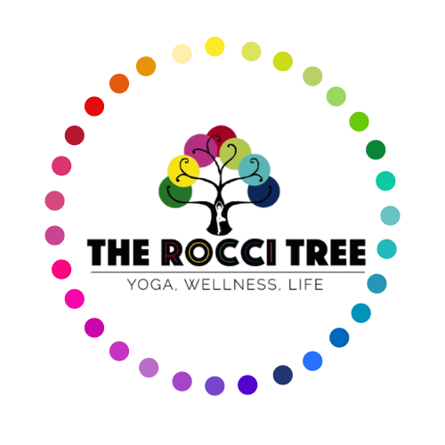
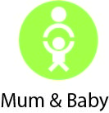
Parent and Baby Yoga Health Questionnaire

Thank you for completing this questionnaire.

All your answers will be kept in complete confidence.

Name: Your Date of Birth:

Baby/ies Name/s: Their Date of Birth:

Contact Number:

Email Address

Address:

Emergency Contact Name and Number:

Please Note - It is important that we have the number of someone to contact if you need them during class.

Previous Experience
Have you done yoga / qi gong before?
What kind(s) of yoga / class you are familiar with:

Non-Postnatal related Health Issues

High /Low blood pressure Heart Disease
Epilepsy Diabetes
Back / neck problems Arthritis / joint problems
Asthma / breathing difficulties Cancer
Eye condition / hearing problems Emotional/psychological problems
Recent operations Other

Please state any particular areas, either physical or emotional, that you would like to gain help with from this class.

Please give details of any medication you take on a regular basis, and what it is for:

You and Your Family Life

What kind of labour did you have?

Were you considered high risk?
If so, in what way?

Do you have any other children?
How many children do you have and what are their ages?

How old is your baby at this time?
Has your baby suffered any medical complications?
Does you baby need any extra support?

Please give details of any complications or miscarriages in previous pregnancies and births:

Do you have any specific health problems related to your pregnancy and labour?
Split abdominal muscles
Pelvic instability
Pain in the pubic bone
Constipation
High blood pressure
Low blood pressure
Haemorrhoids
Varicose veins
Fluid retention
Back or neck pain
Insomnia
Nausea
Other?

Are you breast-feeding?

Have you suffered from baby blues?

Covid-19 – Have you suffered from any lasting effects from a Covid infection or suffered with long Covid? (If Yes, please give details)

Is there anything else you think that your teacher should know?
Please feel free to write down anything as it shall stay within strict confidentiality.

DECLARATION
I take full responsibility for me and my baby/ies health during the Rocci Tree classes, including any injuries. I will inform my teacher of any medical changes.
I understand that my email address will be used to create my Momence account for The Rocci Tree so that I am able to receive details of class bookings, cancellations, purchase receipts and newsletters.
Please contact us if you would like more information about how we will contact you.

Signed: Date:

