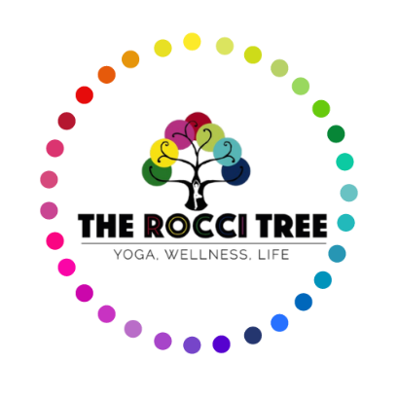
General Health Questionnaire

Name:
Email:
Contact Number:
Emergency Contact Name:
Number:
Please Note - It is important that we have the number of someone to contact if you need them during class.
Occupation:
Date of Birth:

What is your main reason for coming to class?
How did you first hear about The Rocci Tree?

Do any of the following health conditions apply to you? (If Yes, please give details)

High/Low Blood Pressure
Heart Disease/problems
Epilepsy
Diabetes
Back/Neck problems
Knee/Ankle problems
Arthritis/joint problems
Asthma/Breathing difficulties
Recent/on-going dental work
Cancer
Eye condition/Hearing problems
Emotional/Psychological problems
Depression/Anxiety
Recent Operations
Recent Broken Bones/Fractures/Sprains
Pregnancy/Recent Pregnancy (last 9 months)

Covid-19 – Have you suffered from any lasting effects from a Covid infection or suffered with long Covid? (If Yes, please give details)

If there is any other information your teacher needs to know, please write it here:

DECLARATION
I take full responsibility for my health during The Rocci Tree classes, including any injuries.
It is my responsibility to inform my teacher of any medical changes.
I understand that my email address is used to create my Momence account for The Rocci Tree so that I am able to receive details of class bookings, cancellations, purchase receipts and newsletters.
Please contact us if you would like more information about how we will contact you.

Signed:
Date:

