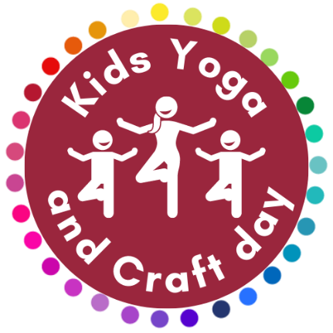
Yoga And Craft Day
Please complete and return before the session
We will need a separate questionnaire for each child

Name of Child:

Age of Child: Date of Birth:

Does your child have any medical conditions that we should be aware of?
(Please make sure you list any special needs/allergies/injuries/medications or anything else that will help your child to have the best day possible)

Is there any other information that may apply or anything that the adults in charge need to know?

Are you happy for us to take photos of our session for use in our newsletter or on our social media pages, that may include your child?
YES NO (Please delete as appropriate)

Are you happy for us to take your child to the park during our session?
YES NO (Please delete as appropriate)

How did you first hear about our Kids Yoga and Craft days?

Full Name of Parent:

Email Address for Parent:

Emergency Telephone Number for Parent:

Second Emergency Contact Person and Number:

What is the Name, Address and Phone Number of your Doctor?

If it becomes necessary for your child to receive medical treatment and you cannot be contacted by telephone or any other means, by signing this form you will give your general consent to any necessary medical treatment and authorise the adults in charge to sign any document required by hospital authorities.

I confirm that my child is sufficiently able to undertake yoga, and that it is my responsibility to inform you of any injuries or concerns they may have.
I understand that yoga includes physical movements, as well as the opportunity for relaxation, and relief of muscular tension.
As is the case with any physical activity, the risk of injury, even serious, is always present and cannot be entirely eliminated. I am also aware that during craft activities there is a possibility of injury due to the use of scissors and other materials, even under supervision.
I affirm that I am responsible to decide whether my child is fit to practise yoga and able to take part in craft activities. I also understand that supportive and encouraging touch, and partner and group interaction is an integral part of this class.
I hereby agree to irrevocably release and waiver any claims that I and/or my child/children have now or, hereafter may have against The Rocci Tree and their staff.
I understand that my email address will be used to create my Momence account for The Rocci Tree so that I am able to receive details of class bookings, cancellations, purchase receipts and newsletters.
Please contact us if you would like more information about how we will contact you.
I confirm I have fully read and understood the terms and conditions relating to these classes.
YES NO (Please delete as appropriate)

Signed: Date:

