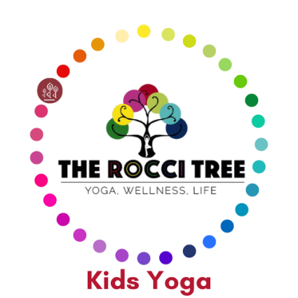
Kids Yoga Health Questionnaire
Please complete and return before attending the first class.
We will need a separate questionnaire for each child

Name of Child:

Age of Child: Date of Birth:

Does your child have any medical conditions that we should be aware of?

Does your child suffer with Asthma or any breathing difficulties?

Has your child had any recent injuries, sprains, fractures or breaks that we should be aware of?

Has your child had any recent operations?

Does your child suffer from any eye conditions or hearing problems?

Has your child had any recent dental work?

Does you child suffer with anxiety?

Does your child suffer with emotional/psychological conditions?

Is there any other information that may apply?

Are you happy for us to take photos of our classes, for use in our newsletter or on our social media pages, that may include your child?
YES NO (Please delete as appropriate)

Full Name of Parent:

Email address for Parent:

Emergency Telephone Number for Parent:

Second Emergency Contact Person and Number:

I confirm that my child is sufficiently able to undertake yoga, and that it is my responsibility to inform you of any injuries or concerns they may have.
Online classes only – As there will not be a teacher in the room with your child, please make sure they take care and listen to their body. Variations will be offered throughout the class so please ensure they only do what they are capable of.
I understand that yoga includes physical movements, as well as the opportunity for relaxation, and relief of muscular tension.
As is the case with any physical activity, the risk of injury, even serious, is always present and cannot be entirely eliminated. I am also aware that during craft activities there is a possibility of injury due to the use of scissors and other materials, even under supervision.
I affirm that I am responsible to decide whether my child is fit to practise yoga, and able to take part in craft activities. I also understand that supportive and encouraging touch, and partner and group interaction is an integral part of this class.
I hereby agree to irrevocably release and waiver any claims that I and/or my child/children have now or, hereafter may have against The Rocci Tree and their staff.
I understand that my email address will be used to create my Momence account for The Rocci Tree so that I am able to receive details of class bookings, cancellations, purchase receipts and newsletters.
Please contact us if you would like more information about how we will contact you.
I confirm I have fully read and understood the terms and conditions relating to these classes.
YES NO (Please delete as appropriate)

Signed:
Date:

