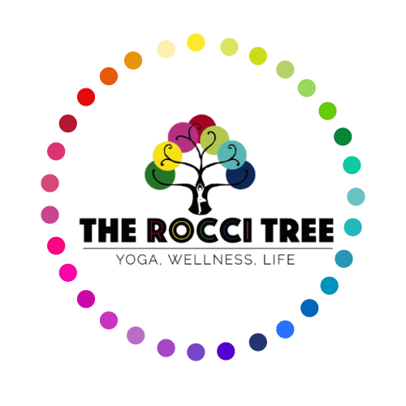
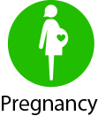
Pregnancy Yoga Health Questionnaire

Thank you for completing this questionnaire.

All your answers will be kept in complete confidence.
Name: Date of Birth:
Address: Post Code:
Email:
Contact Number:
Emergency Contact Name and Number:

Please Note - It is important that we have the number of someone to contact if you need them during class.

Would it be ok to pass your contact number on, if someone in the class asks?

Occupation:
Age group: ☐ 17-30 ☐ 31-36 ☐ 36-40 ☐ 40+
Have you done yoga before?
If yes, what type(s) and for how long?
What is your Estimated Due Date?
How many weeks pregnant are you?
What pre-natal screenings have you had? (Scans, amniocentesis etc)

Is this your first pregnancy?
How many children do you have?
How old are they?
Gynaecological/Obstetrics history (previous complications, miscarriages, IVF)

Is this pregnancy classed as high risk?
If yes, why?
Are you worried about any aspects of the pregnancy?

Non-Pregnancy Related Health Issues
Please mark any which relate to you before you were pregnant.
☐ High /Low blood pressure ☐ Heart disease
☐ Epilepsy ☐ Diabetes
☐ Back / neck problems ☐ Arthritis / joint problems
☐ Asthma / breathing difficulties ☐ Cancer
☐ Eye condition / hearing problems ☐ Emotional/psychological problems
☐ Knee/Ankle problems ☐ Recent fractures/broken bones/sprains
☐ Recent operations ☐ Other

Please give details of any health conditions and how they affect you now:

Please give details of any medication you take on a regular basis, and what it is for:

Do you have any specific health problems related to your pregnancy?
☐ Pelvic instability
☐ Pain in the pubic bone
☐ Constipation
☐ High blood pressure
☐ Low blood pressure
☐ Haemorrhoids
☐ Varicose veins
☐ Fluid retention
☐ Back or neck pain
☐ Insomnia
☐ Nausea
☐ Anxiety
☐ Heartburn
☐ Cramps
☐ Tiredness
☐ Other

Covid-19 – Have you suffered from any lasting effects from a Covid infection or suffered with long Covid? (If Yes, please give details)

Is there anything else you think we should know?
Please feel free to write down anything as it shall stay within strict confidentiality.

How did you first hear about this class?

Declaration:
I take full responsibility for me and my baby/ies health during the classes, including any injuries. I will inform my teacher of any medical changes.
If I feel any pain or dizziness at any time during the yoga class, I will stop the activity immediately and inform my teacher.
If I have any doubts, I will seek the advice of my medical professional before proceeding with Pregnancy classes.
I understand that my email address will be used to create my Momence account for The Rocci Tree so that I am able to receive details of class bookings, cancellations, purchase receipts and newsletters.
Please contact us if you would like more information about how we will contact you.

Signed: Date:

